**Music Composition and Reconstruction Tool**

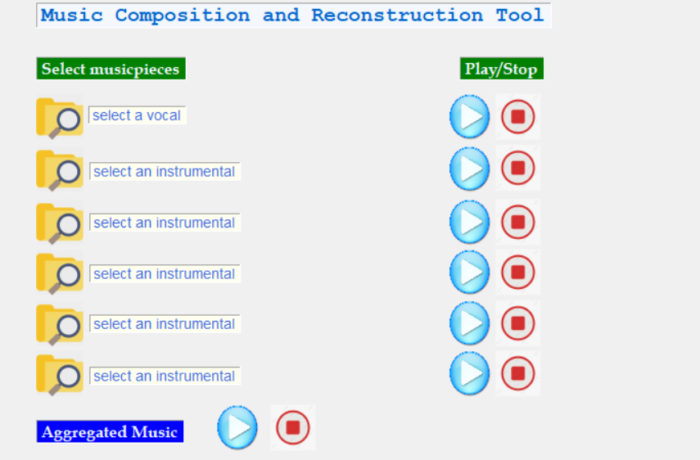

Fig. 1. Before selection of music-pieces.

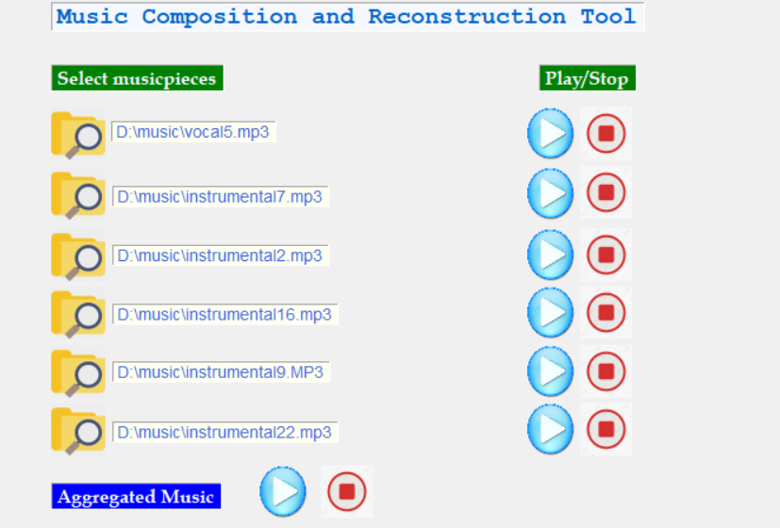

Fig. 2. After selection of music-pieces.